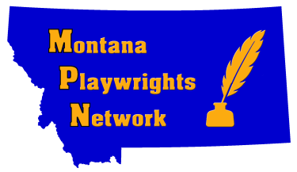

MPN 2019 “Montana Voices” Publication Project Entry Form
(Submit One form per entry)

Name:_________________________________________________________________

Email Address: _________________________________________________________

Telephone: Home:( )___________________ Cell:( ) _______________________

Mailing Address: _____________________________________________________________________

_____________________________________________________________________

Title of work: _________________________________________________________

Type of work: _____Poem _____ Essay ____Short Story ____Storytelling

_____ Play _____ Memoir ___ Stage Monologue

DEADLINE FOR SUBMISSIONS: October 1, 2019

All members of the Montana Playwrights Network (MPN) may submit up to two entries per category. You must be a current member to participate. Send us your best!

Submissions should be unpublished to be eligible for this competition.

Submissions should be submitted as a Word document, or a pdf. The name of the author and category should appear in the upper left corner, along with word count for essays, memoirs, storytelling, and short stories; indicate line count for poetry entries; and page count for plays. For play submissions, submit only in standard manuscript format. If you need guidelines for standard manuscript format, please send inquiry to montanaplaywrights@gmail.com.

Each submission must be accompanied by a completed entry form. (Submission form may be hand written and must be legible.) If submitting more than one entry, each entry must be accompanied by a completed entry form.

Submit your entry to: montanaplaywrights@gmail.com, and label your email subject line as “2019 Montana Voices Submission." Submissions due before or by midnight on October 1, 2019. Any submissions received via email after this date will not be considered.

Questions? Contact Pamela Mencher at montanaplaywrights@gmail.com.

